Diminishing Returns of Electrode Count, Epoch Duration, and Model Complexity in EEG Brain-State Classification
Author and affiliation withheld to preserve anonymity during review.
Abstract
Resting-state electroencephalography (EEG) distinguishes eyes-open from eyes-closed states, a phenomenon documented since Berger described the alpha rhythm in 1929¹, so reporting a high classification accuracy for this contrast adds little; the consequential question is how few resources such classification actually requires. This study quantified the marginal contribution of electrode count, epoch duration, and model complexity using the 61-second eyes-open and eyes-closed baseline recordings of 109 adults (64 channels, 160 Hz) from the PhysioNet EEG Motor Movement/Imagery Dataset, of whom 106 provided usable data in both conditions. Recordings were band-pass filtered (1–45 Hz), average-referenced, segmented into 2-second epochs, and reduced to 674 spectral features; all partitions were made over participants rather than epochs, and confidence intervals came from a cluster bootstrap resampling participants. Occipital relative alpha power increased with eye closure in 106 of 106 participants (mean difference +0.292, d_{z} = +1.60). A single occipital alpha feature achieved an area under the receiver operating characteristic curve (AUC) of 0.830, whereas 674 features achieved 0.894, and no model family separated from another by more than 0.004 AUC. Reducing 64 electrodes to 19 cost 0.005 AUC, and one occipital electrode retained 0.817. Splitting epochs rather than participants inflated AUC from 0.893 to 0.940. Performance in this paradigm is therefore constrained by physiology and recording duration rather than by feature engineering or model capacity; for low-cost systems targeting this class of contrast, budget spent on electrode placement and window length returns more than budget spent on channel count or model sophistication.
Keywords. electroencephalography; alpha rhythm; brain-state classification; machine learning; data leakage
Introduction
Electroencephalography (EEG) records the summed postsynaptic potentials of large, spatially aligned cortical neuron populations at the scalp. It has millisecond temporal resolution, poor spatial resolution, and — importantly for applications — an equipment cost that ranges across four orders of magnitude, from research systems with 64 or 256 gel electrodes to consumer headbands with a single dry frontal contact. EEG activity is conventionally divided into frequency bands: delta (1–4 Hz), theta (4–8 Hz), alpha (8–13 Hz), beta (13–30 Hz), and gamma (>30 Hz). Band power in these ranges is the standard descriptive vocabulary for resting-state EEG and the standard feature basis for classification.
Berger's 1929 report of the human alpha rhythm already described its central phenomenon: a roughly 10 Hz posterior oscillation that is prominent with the eyes closed and attenuates on eye opening¹. The effect has been quantified repeatedly since, most systematically by Barry et al., who documented the topography and band specificity of the eyes-open/eyes-closed difference in adults², and by Barry and De Blasio, who showed that it persists in healthy ageing³. Mechanistically, the modern account is not that alpha reflects cortical idling but that it reflects active inhibition. The gating-by-inhibition framework⁴ and the inhibition-timing account⁵ both treat alpha as pulsed suppression of task-irrelevant input; Pfurtscheller and Lopes da Silva describe the desynchronization that follows sensory input⁶, and Hughes and Crunelli locate the generator in thalamocortical loops⁷. A study whose contribution is a high eyes-open/eyes-closed classification accuracy therefore contributes essentially nothing; the separability is not in doubt.
What is genuinely undetermined, and practically consequential, is the cost at which the separation can be achieved. A designer choosing hardware faces concrete questions with non-obvious answers. How many electrodes are needed, and does it matter where they go? How long must each recording window be, and can extra time substitute for missing electrodes? Does a machine-learning pipeline over hundreds of features earn its complexity relative to thresholding a single band-power value?
The last question matters beyond this contrast. EEG classification papers routinely report elaborate pipelines without a simple-feature baseline, so it is often impossible to tell how much of the reported performance comes from the method rather than the physiology^{8,9}. Measuring the marginal value of complexity directly is more informative than one more accuracy figure.
Primary question. How far can electrode count, recording window length, and model complexity be reduced before eyes-open / eyes-closed classification degrades meaningfully, and what is the marginal value of machine-learning complexity over a single physiologically motivated feature? Three hypotheses follow. H1: a single occipital relative-alpha feature will come within a small margin of a full multivariate model, because the underlying effect is large and low-dimensional. H2: performance will saturate at a small number of electrodes, with placement mattering more than count at small budgets. H3: window length will trade off against electrode count, since both increase the effective evidence per decision. A subordinate confirmatory question is whether the classical alpha effect replicates in this dataset at all; if it does not, the cost analysis would be meaningless.
Methods
Research design and dataset:
I used the PhysioNet EEG Motor Movement/Imagery Dataset (eegmmidb) v1.0.0^{10,11}, recorded with the BCI2000 system¹². The dataset contains 109 participants recorded at 64 channels (10-10 extended system) and 160 Hz under the Open Data Commons Attribution License v1.0. Only the two baseline runs were used: R01 (eyes open) and R02 (eyes closed), each 61 s long, so that run identity supplies the condition label. Each participant therefore contributed one eyes-open and one eyes-closed baseline, giving a fully paired within-participant design. This dataset was chosen over alternatives because 109 participants is large enough for participant-level cross-validation to be meaningful, because the two baseline runs give a clean binary contrast without task confounds, and because its permissive license allows redistribution and independent verification.
Provenance and integrity. All 218 files were retrieved directly from PhysioNet, and each was hashed and compared against the official SHA-256 manifest before use: 218 of 218 matched exactly, with zero mismatches. The check is not ceremonial. During development an earlier run left simulated test recordings on disk under real filenames; the hash comparison identified all 16 and deleted them rather than analysing them as data. A file that does not match its published hash is discarded, never used. The complete pipeline, together with the numerical results, figures, and provenance record underlying every value reported here, is archived under a permanent identifier¹³.
Preprocessing:
Preprocessing was implemented with MNE-Python¹⁴, following artifact-handling conventions established in EEGLAB¹⁵. Each decision and its rationale is given below.
(1) Channel-name standardization and montage. Raw EDF labels are dot-padded (Fc5., C5..); these were mapped to 10-10 names¹⁶ and the standard_1005 montage attached. This is required for interpolation and topographic plotting and does not alter the signal.
(2) Band-pass 1–45 Hz, zero-phase FIR. The 1 Hz high-pass removes drift and sweat artifact. The 45 Hz low-pass sits below the 60 Hz US mains frequency, so no notch filter is required. Both edges were fixed a priori and applied identically to both conditions, so the filter cannot manufacture a group difference. Possible bias: the 1 Hz high-pass attenuates the lower delta range, so delta estimates here are conservative.
(3) Bad-channel detection and interpolation. A channel was marked bad if flat, if its log-variance was an extreme robust-z outlier (z > 6), or if its maximum absolute correlation with every other channel fell below 0.30¹⁷. The correlation criterion is essential: a first attempt using a plain variance-outlier rule flagged all six frontal electrodes on the first participant, because frontal channels legitimately carry high variance from ocular activity rather than being broken. The final rule flagged 123 channels across 216 recordings (0.57 per recording), affecting 76 recordings and 56 of 109 participants; 140 recordings had none. The flags are strongly structured rather than scattered, which is itself evidence that the rule is finding hardware faults rather than noise. Only 28 of 64 electrode positions were ever flagged. T10 alone accounts for 45 of the 123 (37%), and with its left counterpart T9 the inferior temporal pair makes up 41% of all flags — these sit at the lower edge of the cap, where contact is hardest to maintain. In 21 cases the same electrode was flagged in both runs of one participant, the signature of a persistently faulty contact rather than transient noise. Two recordings lost a whole frontal cluster of seven and eight electrodes, consistent with a lifted frontal strip. Detection used within-recording statistics only and never saw the condition label.
(4) Average reference, applied after interpolation so that a bad channel is not smeared across the montage. These recordings have no usable physical reference. Possible bias: an average reference subtracts the mean across electrodes and therefore attenuates spatially broad activity. This is the one preprocessing choice that materially affected results.
(5) Fixed-length non-overlapping 2-second epochs. Non-overlapping windows keep samples closer to independent; overlapping windows would inflate the apparent sample size.
(6) Epoch rejection. An epoch was discarded if more than 20% of channels exceeded a 250 µV peak-to-peak swing. The conventional maximum-peak-to-peak-across-all-channels rule is inappropriate for a 64-channel montage: the maximum is dominated by the single noisiest electrode, and at the usual 150 µV threshold it discarded 97% of epochs in this dataset. The fraction-based rule targets global artifacts (movement, muscle bursts) instead. The threshold pair was fixed before any classification was run, using only the pooled amplitude distribution and one explicit constraint — that rejection rates be balanced across conditions, since differential data loss would itself be a confound. At these values 84.8% of eyes-open and 92.2% of eyes-closed epochs survived. The residual imbalance is examined in the Limitations and in the robustness analysis.
Independent component analysis (ICA) was deliberately not applied by default. These are 61-second recordings with no EOG or ECG channels, so ocular components would have to be identified heuristically rather than by correlation with a reference signal, and misidentification would remove genuine frontal activity¹⁸. ICA was instead evaluated as a robustness condition.
Quality control. 106 of 109 participants were usable. Three (S009, S022, S060) lost an entire condition to artifact rejection and were excluded, since a paired design requires both. Retained participants contributed on average 25.9 eyes-open and 27.9 eyes-closed epochs, giving 5,704 epochs (2,745 eyes open, 2,959 eyes closed).
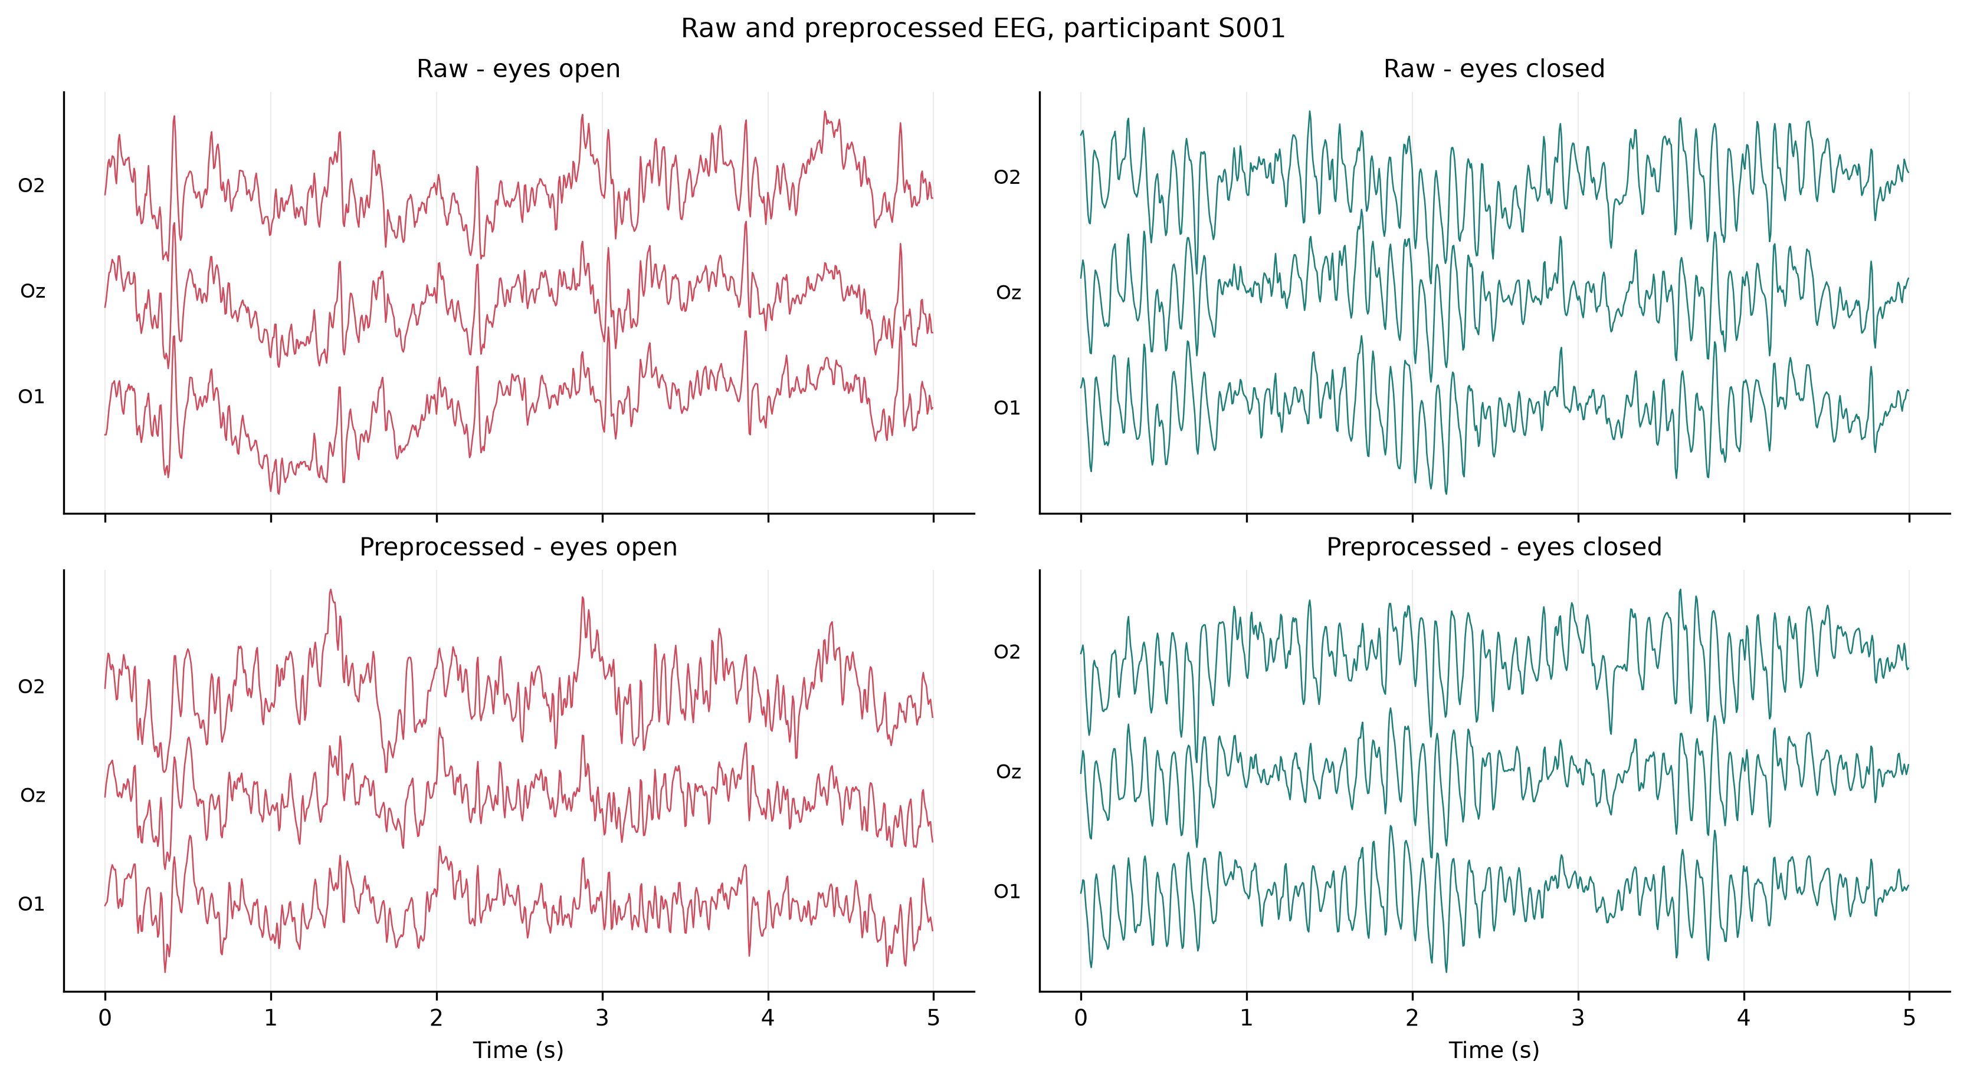
Figure 1. Raw versus preprocessed EEG for one participant in both conditions.
Variables and feature extraction:
Power spectral density was estimated per epoch by Welch's method¹⁹ using 1-second Hann segments with 0.8-second overlap (six averaged segments per 2-second epoch, 1 Hz resolution). Band edges followed the conventional definitions endorsed by the IFCN EEG research workgroup²⁰. Each epoch yielded 674 features, summarized in Table 1.
Table 1. The 674 spectral features extracted from each 2-second epoch.
Family | Count | Description
logabs_<ch>_<band> | 320 | log₁₀ absolute band power (µV²). Log scale because EEG power is strongly right-skewed.
rel_<ch>_<band> | 320 | Band power ÷ total 1–45 Hz power. Insensitive to overall gain differences, so more comparable across participants.
region_<region>_<band> | 25 | Mean relative power over frontal / central / temporal / parietal / occipital sites.
global_<band> | 5 | Mean relative power across all channels.
Derived | 4 | Occipital alpha/theta and alpha/beta log ratios, occipital alpha asymmetry, individual alpha peak frequency.

Individual alpha peak frequency was retained as a derived feature because alpha frequency varies systematically between individuals²¹. Nothing is fitted across epochs, so feature extraction cannot leak information between participants. Standardization was deferred to the modeling stage and fitted inside each cross-validation fold.
Prevention of data leakage:
Each participant contributes roughly 54 epochs that share their skull thickness, electrode placement, alpha peak frequency, and overall amplitude. A model given epochs from the same person on both sides of a split can identify the person and recall their condition rather than learning anything about brain state^{22,23}. Accordingly:
(1) The held-out set was formed by GroupShuffleSplit over participants (30%), yielding 74 training and 32 held-out participants, and was untouched until final evaluation.
(2) Hyperparameter searches used GroupKFold over training participants only.
(3) All scaling was fitted inside folds via scikit-learn Pipeline objects²⁴.
(4) Leave-one-subject-out (LOSO) cross-validation over all 106 participants provides a second, more demanding generalization estimate.
(5) An assertion in the training code verifies that no participant appears on both sides of the split.
Data analysis:
The unit of analysis is the participant, not the epoch. Averaging each participant's epochs before testing avoids pseudoreplication; testing at the epoch level would inflate the effective sample size roughly fiftyfold. Because every participant provides both conditions, comparisons are paired: paired t-tests with Wilcoxon signed-rank as a distribution-free check, Cohen's d_{z} with 95% confidence intervals on the mean paired difference, and Benjamini–Hochberg false discovery rate control at q < 0.05 across the 320 channel × band comparisons²⁵.
Relative band power is compositional — the five bands sum to one, so a genuine rise in one band mechanically depresses every other. I therefore repeated the tests on log absolute power to distinguish real changes from renormalization artifacts.
Model comparison used a dummy classifier (most-frequent), logistic regression, linear SVM, random forest, and histogram gradient boosting, tuned by grid search where a grid applied. The complexity sweep held the learner fixed at logistic regression with the selected C = 0.01 and varied only the data, because re-tuning per configuration would confound "this configuration carries more information" with "this configuration got a luckier search". Electrode budgets were compared against random same-size electrode subsets (10 draws each), so that an informed placement can be judged against an arbitrary one.
Confidence intervals use a cluster bootstrap resampling participants with replacement (2,000 draws for headline models). An ordinary bootstrap over epochs would treat ~54 dependent observations as independent and report intervals several times too narrow²⁶.
Ethical considerations and availability:
All EEG recordings analyzed here are from the EEG Motor Movement/Imagery Database v1.0.0, archived at PhysioNet under the Open Data Commons Attribution License v1.0¹⁰. The complete analysis pipeline, the numerical results underlying every value reported here, the published figures, and the checksum verification record are archived under a permanent identifier, cited in the published version¹³. The pipeline reproduces end to end with a single command, and random seeds are fixed at 42 throughout. Analyses used MNE-Python¹⁴ and scikit-learn²⁴. No new data were generated for this study, no human participants were recruited, and no new recordings were made, so institutional review board approval was not required for this secondary analysis of fully de-identified public data. This research received no funding, and the author declares no competing interests.
Results
Replication of the classical alpha effect:
Occipital (O1/Oz/O2) relative alpha power was higher with eyes closed in 106 of 106 participants — every single one. The mean paired difference was +0.292 (95% CI [+0.257, +0.327]), d_{z} = +1.60, t(105) = 16.45, p = 8.1 × 10⁻³¹; the distribution-free Wilcoxon check agreed (p = 4.0 × 10⁻¹⁹). Of the 320 channel × band comparisons on log absolute power, 233 survived Benjamini–Hochberg correction at q < 0.05.
Separating genuine change from compositional renormalization was informative (Table 2, Figure 3). Two findings would have been missed by reporting relative power alone. Theta's apparent decrease is entirely a renormalization artifact: its absolute power does not change reliably (q = 0.079). Beta's apparent slight decrease in relative power conceals a substantial genuine increase in absolute power (d_{z} = +1.21, a 1.7-fold rise). In absolute terms occipital alpha power rises 5.4-fold on eye closure. The eight largest single-channel effects in the entire dataset are all alpha-band and all posterior: PO8 (d_{z} = +1.68), O2 (+1.66), O1 (+1.64), Oz (+1.58), Iz (+1.57), PO4 (+1.57), PO3 (+1.56) and PO7 (+1.56). No non-alpha, non-posterior effect comes close.
Table 2. Whole-scalp relative power versus occipital log absolute power, eyes closed minus eyes open (n = 106).
Band | Rel. Δ | Rel. d_{z} | Rel. q | Abs. Δ | Abs. d_{z} | Abs. q | Interpretation
Delta | −0.112 | −1.13 | 3.5×10⁻²⁰ | −0.149 | −0.54 | 3.8×10⁻⁷ | Genuine decrease (0.71×)
Theta | −0.019 | −0.49 | 3.0×10⁻⁶ | +0.042 | +0.17 | 0.079 n.s. | Compositional artifact
Alpha | +0.170 | +1.41 | 3.8×10⁻²⁶ | +0.735 | +1.65 | 3.5×10⁻³¹ | Genuine, large (5.4× power)
Beta | −0.015 | −0.24 | 0.015 | +0.231 | +1.21 | 4.8×10⁻²² | Genuine rise (1.7×), hidden by rel. power
Gamma | −0.025 | −0.68 | 4.7×10⁻¹⁰ | +0.025 | +0.22 | 0.034 | Genuine, masked by rel. power
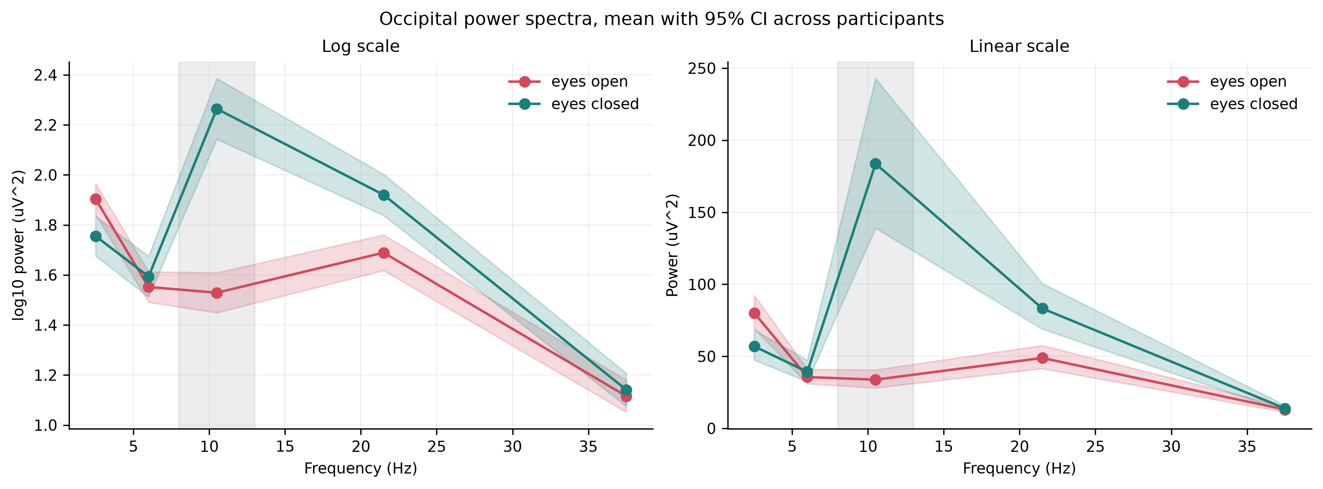
Figure 2. Occipital power spectra, mean with 95% confidence interval across participants.
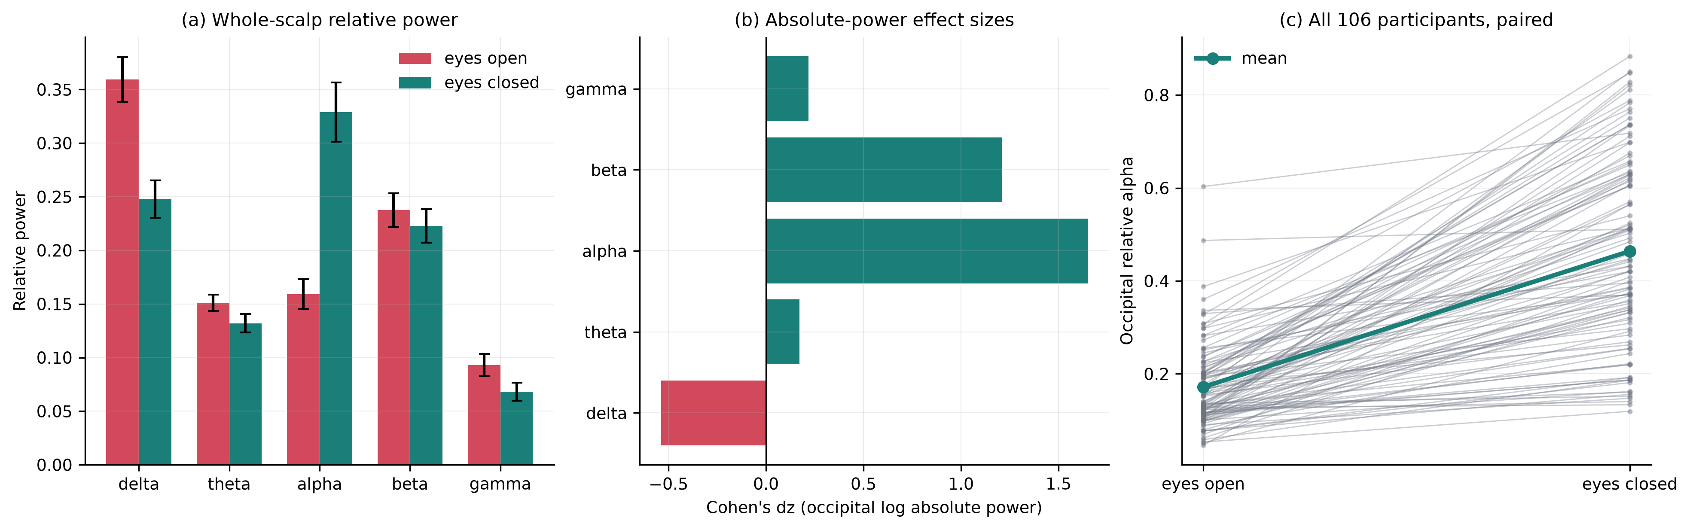
Figure 3. (a) Whole-scalp relative power by condition. (b) Occipital absolute-power effect sizes. (c) Every one of 106 participants, paired.
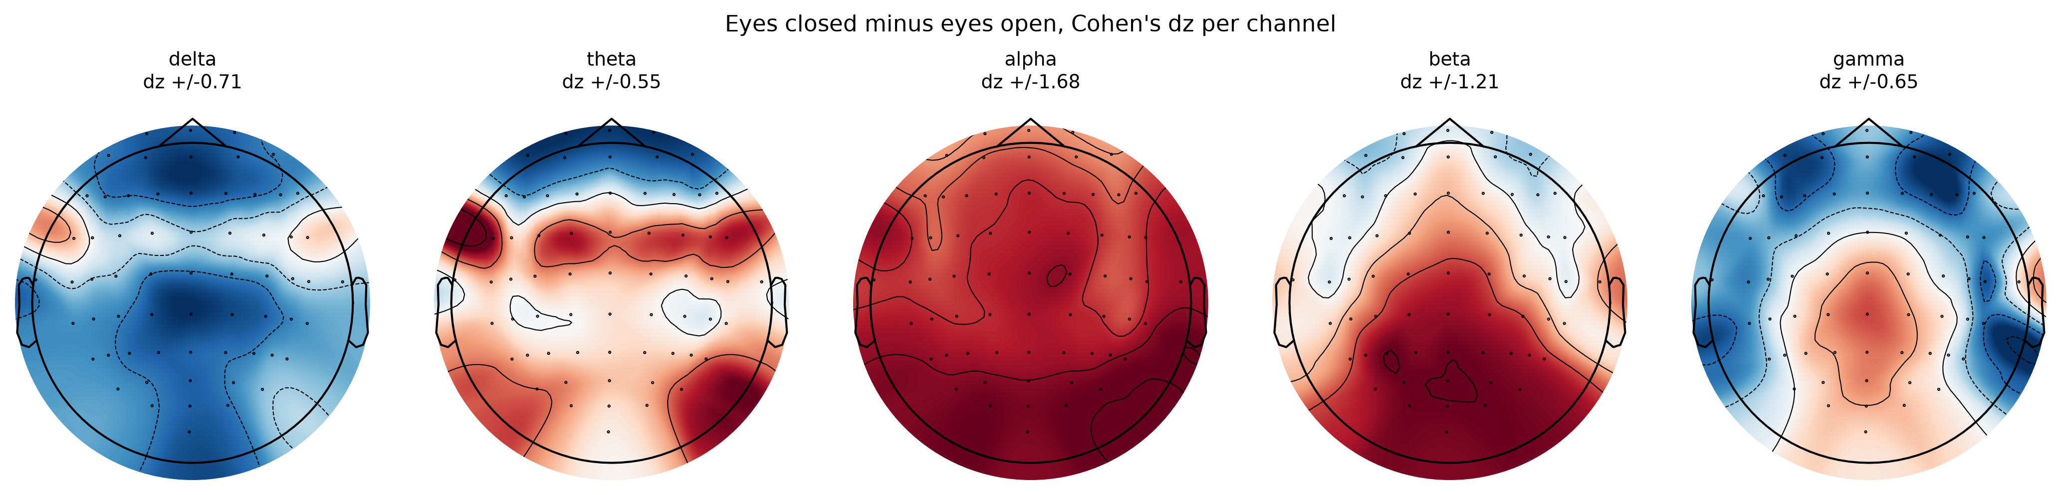
Figure 4. Scalp topography of the eyes-closed minus eyes-open difference, by band.
Feature richness and model complexity:
Table 3. Feature ladder, held-out participants (n = 32). Logistic regression throughout except the dummy baseline. Cluster-bootstrap 95% confidence intervals.
Feature set | n feat. | Accuracy [95% CI] | ROC-AUC [95% CI] | F1 | Sens. | Spec.
Dummy baseline | — | 0.514 [0.504, 0.525] | 0.500 | 0.679 | 1.000 | 0.000
Single occipital alpha (Oz) | 1 | 0.751 [0.693, 0.811] | 0.830 [0.776, 0.883] | 0.717 | 0.614 | 0.896
Whole-scalp band powers | 5 | 0.691 [0.632, 0.752] | 0.777 [0.714, 0.841] | 0.681 | 0.641 | 0.743
Per-channel relative power | 320 | 0.799 [0.745, 0.853] | 0.883 [0.834, 0.929] | 0.786 | 0.718 | 0.885
All features | 674 | 0.801 [0.749, 0.853] | 0.894 [0.849, 0.937] | 0.794 | 0.746 | 0.859

The entire return on going from one feature to 674 is +0.064 AUC and +5.0 accuracy points (Table 3), and the confidence intervals overlap heavily: the single-feature interval [0.776, 0.883] contains most of the full-feature interval [0.849, 0.937]. H1 is supported.
A non-obvious result: five whole-scalp band powers (AUC 0.777) perform worse than one occipital channel (0.830). Averaging band power across the scalp destroys the spatial localization that makes alpha diagnostic — a spatially specific effect is diluted by 64 channels, most of which carry little signal.
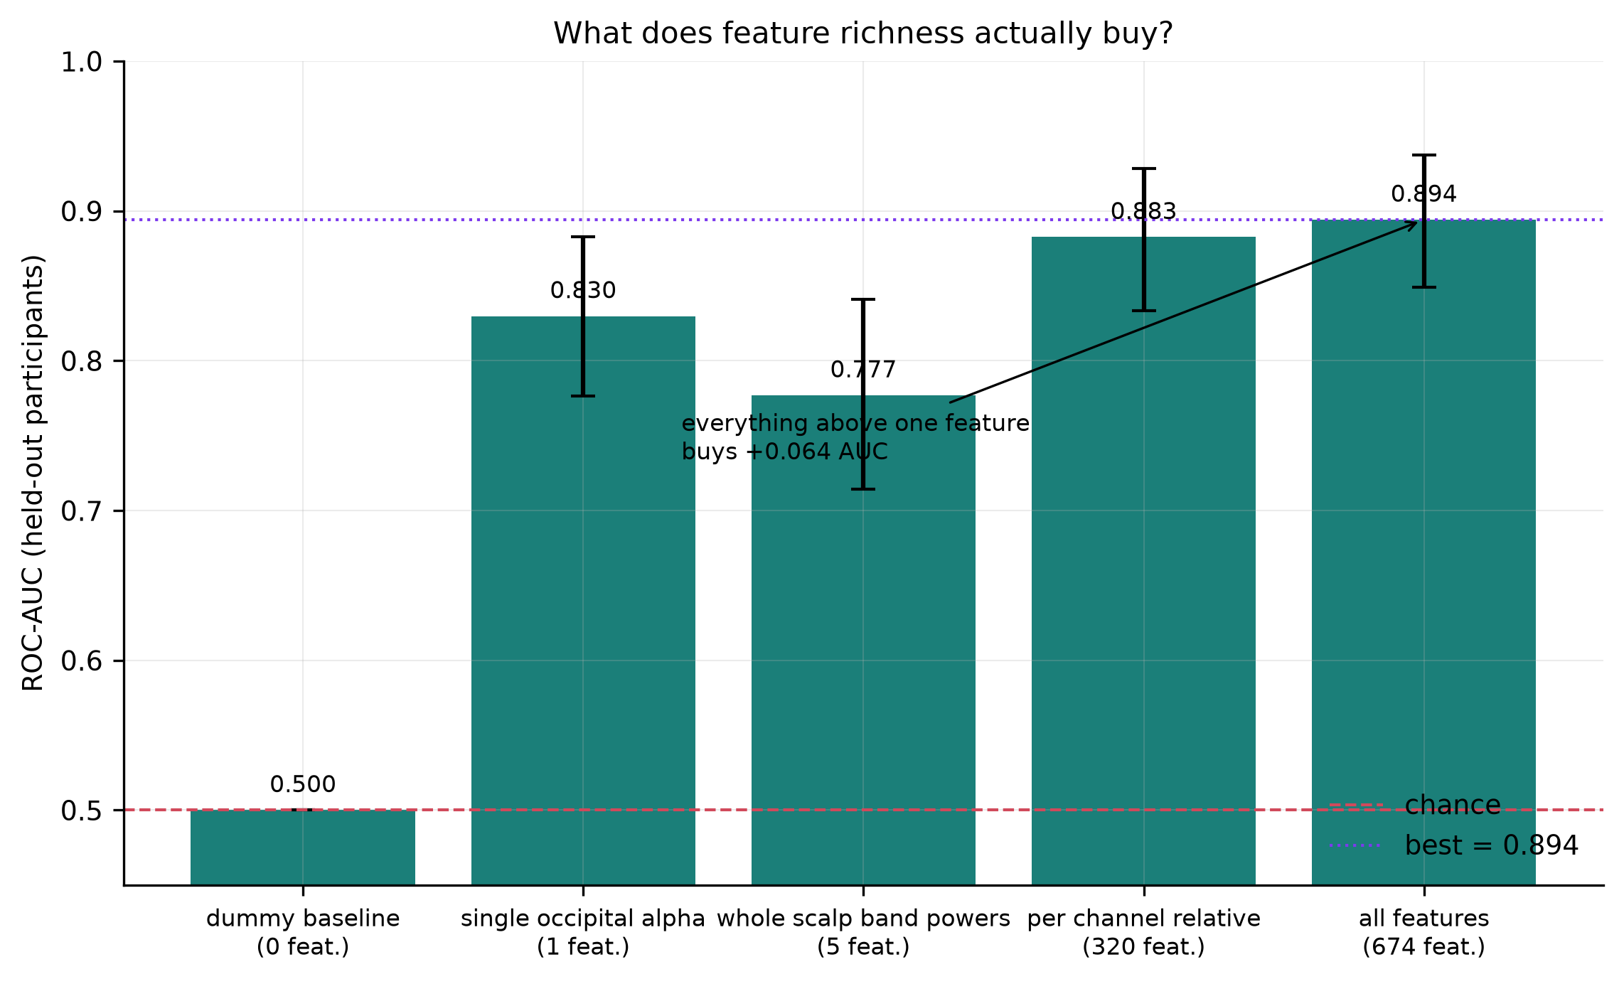
Figure 5. What feature richness buys. The gap between one feature and 674 is smaller than the inflation caused by leaky cross-validation.
Table 4. Model comparison, all 674 features, held-out participants.
Model | Accuracy [95% CI] | ROC-AUC [95% CI] | Prec. | Recall | F1
Hist. gradient boosting | 0.791 [0.742, 0.842] | 0.897 [0.861, 0.935] | 0.854 | 0.716 | 0.779
Logistic regression (C = 0.001) | 0.793 [0.738, 0.847] | 0.893 [0.852, 0.933] | 0.862 | 0.711 | 0.780
Linear SVM (C = 0.001) | 0.798 [0.745, 0.851] | 0.891 [0.846, 0.936] | 0.847 | 0.742 | 0.791
Random forest | 0.775 [0.722, 0.832] | 0.876 [0.836, 0.919] | 0.866 | 0.666 | 0.753
Dummy | 0.514 [0.504, 0.525] | 0.500 | 0.514 | 1.000 | 0.679

Model family bought essentially nothing (Table 4). The spread across four very different learners is 0.021 AUC, and the top three — gradient boosting 0.897, logistic regression 0.893, linear SVM 0.891 — fall within 0.006 of one another, far inside their overlapping confidence intervals. Gradient boosting is nominally best, but 0.004 AUC over a penalized linear model is not evidence that nonlinearity is doing work; the honest reading is that model capacity is not the binding constraint here. Both linear models selected the strongest available regularization (C = 0.001), which points the same way. The confusion matrix for logistic regression shows 768 / 105 / 267 / 658 (TN/FP/FN/TP), that is, specificity 0.880 exceeding sensitivity 0.711 — the model is more reliable when it declares "eyes open".
Quantifying leakage from epoch-level splitting:
To quantify what participant-level splitting protects against, I repeated the headline analysis with an ordinary random split over epochs, so that the same participant could appear in both training and test data. Everything else was identical. Accuracy rose from 0.793 to 0.852 and AUC from 0.893 to 0.940.
The inflation produced by this single methodological error (+0.048 AUC, +0.059 accuracy) is of the same order as the entire benefit of adding 673 features (+0.064 AUC), and larger than the whole spread across every model family tested (0.021 AUC). A study that splits epochs at random and reports a large gain from an elaborate pipeline may be reporting mostly leakage. This is the strongest practical argument for the design used here.
Electrode count and placement:
Table 5. Electrode ablation, 2-second windows, held-out participants.
Electrode set | n | ROC-AUC | Accuracy | Random same-size (mean of 10)
All channels | 64 | 0.894 | 0.801 | —
10-20 subset | 19 | 0.889 | 0.781 | 0.868 (0.846–0.888)
Occipital region | 9 | 0.844 | 0.754 | 0.847 (0.820–0.864)
O1/Oz/O2 | 3 | 0.830 | 0.742 | 0.806 (0.728–0.862)
Oz only | 1 | 0.817 | 0.741 | 0.763 (0.685–0.824)
Frontal headband (Fp1/Fpz/Fp2) | 3 | 0.776 | 0.684 | 0.791 (0.766–0.843)
Frontal headband (Fpz) | 1 | 0.739 | 0.663 | 0.755 (0.697–0.824)

Dropping 45 of 64 electrodes cost 0.005 AUC (Table 5). Dropping to a single occipital electrode cost 0.077 — it retained 80% of the above-chance AUC of the full montage.
The comparison against random subsets is the informative part. At one electrode, informed occipital placement beat random placement by +0.054 AUC (0.817 vs 0.763); at three, by +0.024. At nine the advantage vanished entirely and was nominally negative (0.844 vs 0.847). Placement matters when electrodes are scarce and stops mattering once about nine are spread over the scalp. H2 is supported, with one caveat: the random baseline comes from only ten draws and is itself noisy — at one electrode those draws ranged from 0.685 to 0.824, so a lucky arbitrary placement can match an informed one.
A frontal headband electrode (Fpz, AUC 0.739) performed slightly worse than a randomly chosen electrode (0.755) and 0.078 below Oz — the placement consumer hardware adopts for mechanical convenience is close to the worst choice for this particular contrast.
Recording time as a substitute for electrodes:
Table 6. Window length, all 64 channels.
Window | Participants | Test epochs | Accuracy | ROC-AUC [95% CI]
0.5 s | 109 | 7,865 | 0.772 | 0.864 [0.822, 0.903]
1.0 s | 109 | 3,816 | 0.789 | 0.879 [0.839, 0.920]
2.0 s | 106 | 1,798 | 0.801 | 0.894 [0.851, 0.940]
4.0 s | 99 | 774 | 0.860 | 0.938 [0.899, 0.971]
8.0 s | 84 | 303 | 0.822 | 0.917 [0.868, 0.963]

AUC rose steadily with window length through 4 seconds, from 0.864 at 0.5 s to 0.938 at 4 s (Table 6). The 8-second condition scored lower (0.917), but this is almost certainly attrition rather than a genuine decline: a 61-second run yields only seven 8-second epochs, and artifact rejection eliminated an entire condition for 22 participants, leaving 84. The 8-second estimate therefore rests on a smaller and different sample from the rest of the curve and should not be read as saturation. Crossing the two axes gives a trade-off surface (Table 7, Figure 6c).
Table 7. ROC-AUC across the electrode × window trade-off surface.
Electrode set | 0.5 s | 1 s | 2 s | 4 s | 8 s
64 (all) | 0.864 | 0.879 | 0.894 | 0.938 | 0.917
19 (10-20) | 0.824 | 0.843 | 0.889 | 0.928 | 0.902
9 (occipital) | 0.813 | 0.848 | 0.844 | 0.899 | 0.887
3 (O1/Oz/O2) | 0.792 | 0.829 | 0.830 | 0.890 | 0.888
1 (Oz) | 0.771 | 0.814 | 0.817 | 0.886 | 0.878
1 (Fpz, headband) | 0.732 | 0.774 | 0.739 | 0.850 | 0.875

One occipital electrode with an 8-second window (0.878) exceeds 64 electrodes with a 0.5-second window (0.864), and one electrode at 4 seconds (0.886) exceeds nineteen electrodes at 1 second (0.843). Recording time does not merely substitute for electrodes; past a short window it dominates them. H3 is supported.
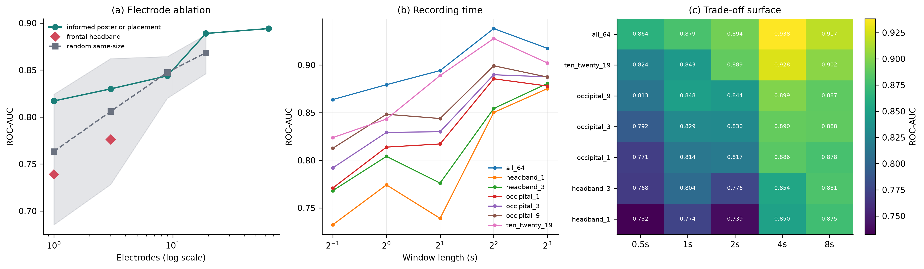
Figure 6. Primary result. (a) Electrode ablation against random same-size subsets. (b) Window-length curves per electrode budget. (c) The trade-off surface.
Robustness to preprocessing choices:
Table 8. Robustness across 15 preprocessing configurations. Main-analysis settings in bold.
Analysis | Setting | ROC-AUC
Artifact rejection | none / 200 µV / 250 µV (main) / 350 µV | 0.894 / 0.889 / 0.894 / 0.911
Feature family | all / relative / absolute / alpha only / excl. alpha | 0.894 / 0.883 / 0.900 / 0.873 / 0.892
Referencing | average (main) / none | 0.894 / 0.869
Band definition | standard / alt (alpha 7–13 Hz) | 0.894 / 0.893
ICA | not applied (main) / applied (Fp1 proxy) | 0.894 / 0.867

Across 15 configurations AUC spanned 0.867–0.911 (Table 8, Figure 9). Three points deserve emphasis. First, artifact rejection is essentially irrelevant: performance with no rejection at all is identical to the main setting (0.894), so the differential rejection between conditions is not driving any result. Second, the two choices that do matter cost about the same and both concern what is removed from the signal — dropping the average reference costs 0.025 AUC, applying ICA costs 0.027. Third, that ICA result is the reverse of a null: it retrospectively justifies leaving ICA off, because heuristic component selection without an EOG channel removes genuine signal along with artifact, exactly as the Methods anticipated.
Most striking is the feature-family row. Removing every alpha feature costs only 0.002 AUC (0.894 → 0.892), while alpha features alone reach 0.873. The information is heavily redundant across bands, because eye closure changes the whole spectrum, not alpha in isolation.
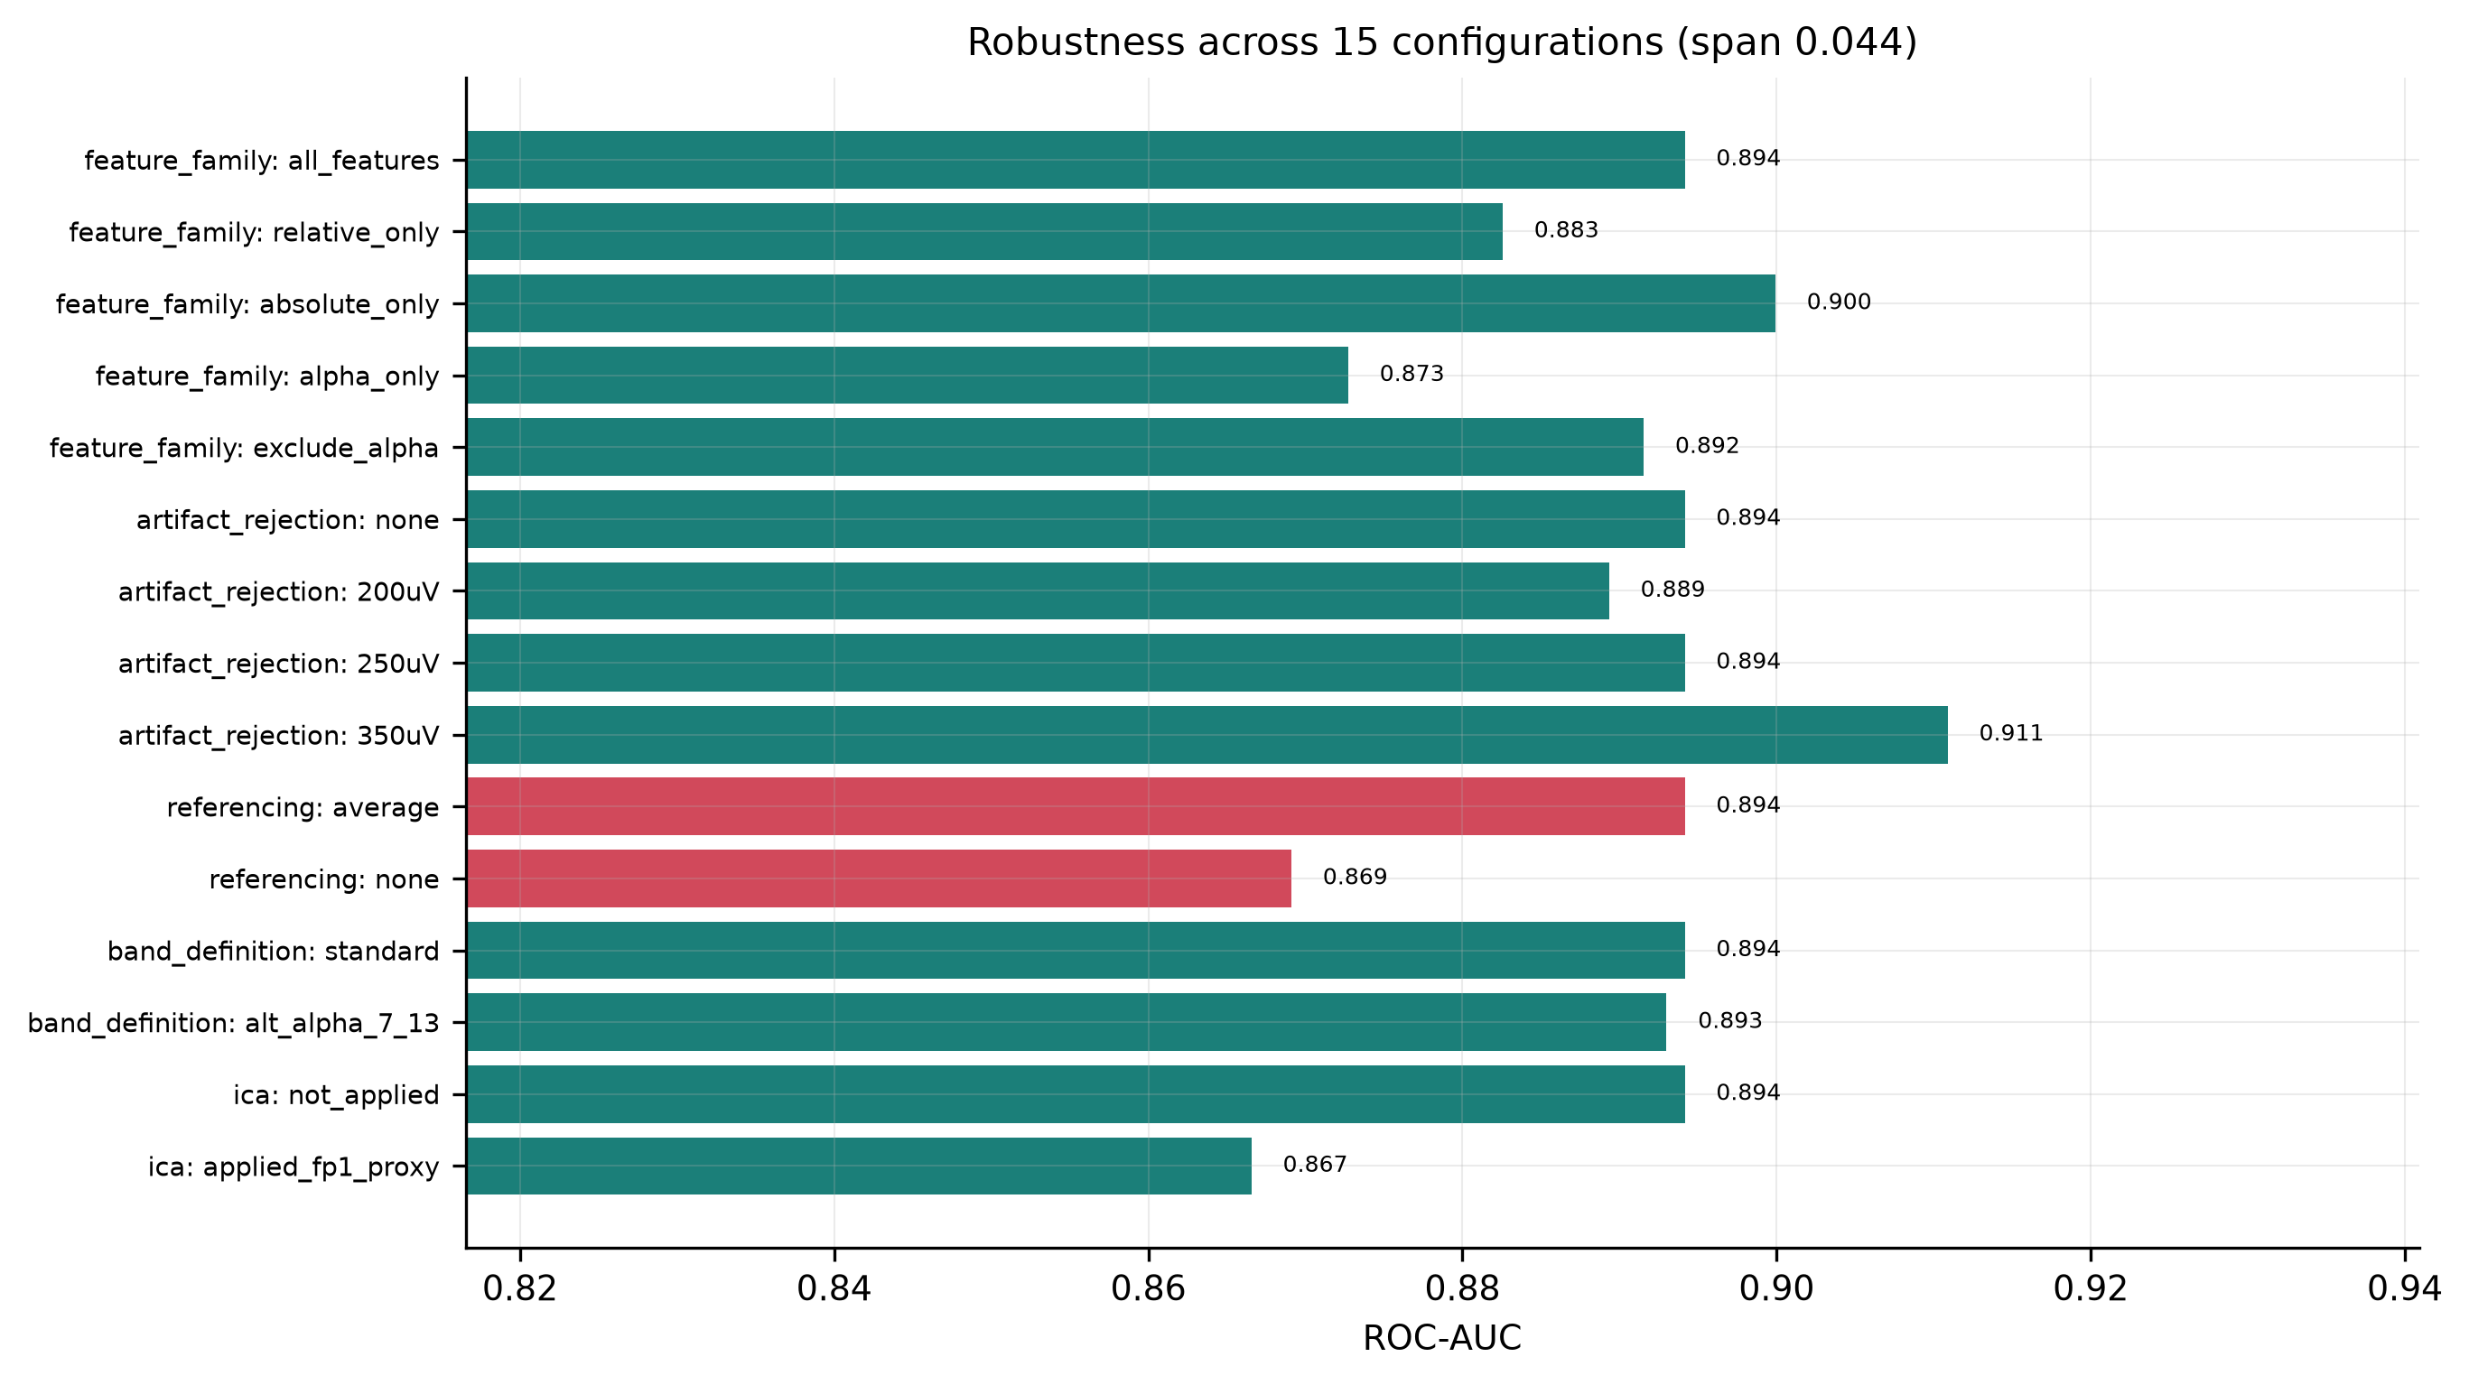
Figure 7. Robustness across 15 preprocessing configurations. Only re-referencing and ICA materially change the result.
Feature importance and its limitations:
Summed permutation importance on the held-out set ranked bands: beta (+0.0368) > gamma (+0.0289) > alpha (+0.0174) > delta (+0.0080) > theta (+0.0070). Top individual features were logabs_Iz_beta, logabs_Iz_alpha, rel_AF8_gamma, and logabs_Fpz_gamma; summed by electrode, Iz (inion) ranked first by a factor of two over the next site. Iz is the most posterior electrode in the montage.
This ranking directly contradicts the univariate statistics, and the contradiction is instructive rather than a result. In the paired tests alpha is by far the largest effect (d_{z} = +1.65) while beta is smaller (+1.21). Permutation importance behaves badly with correlated features: alpha information is duplicated across dozens of posterior electrodes, so permuting any single alpha feature barely degrades the model, which finds the same information elsewhere. Beta is somewhat less redundant and so appears more important. The ablation above resolves the question properly — removing all alpha features costs almost nothing precisely because the information is redundant, not because alpha is unimportant. Permutation importance on correlated feature sets measures redundancy, not relevance, and should not be read as a claim about which rhythm carries the signal.
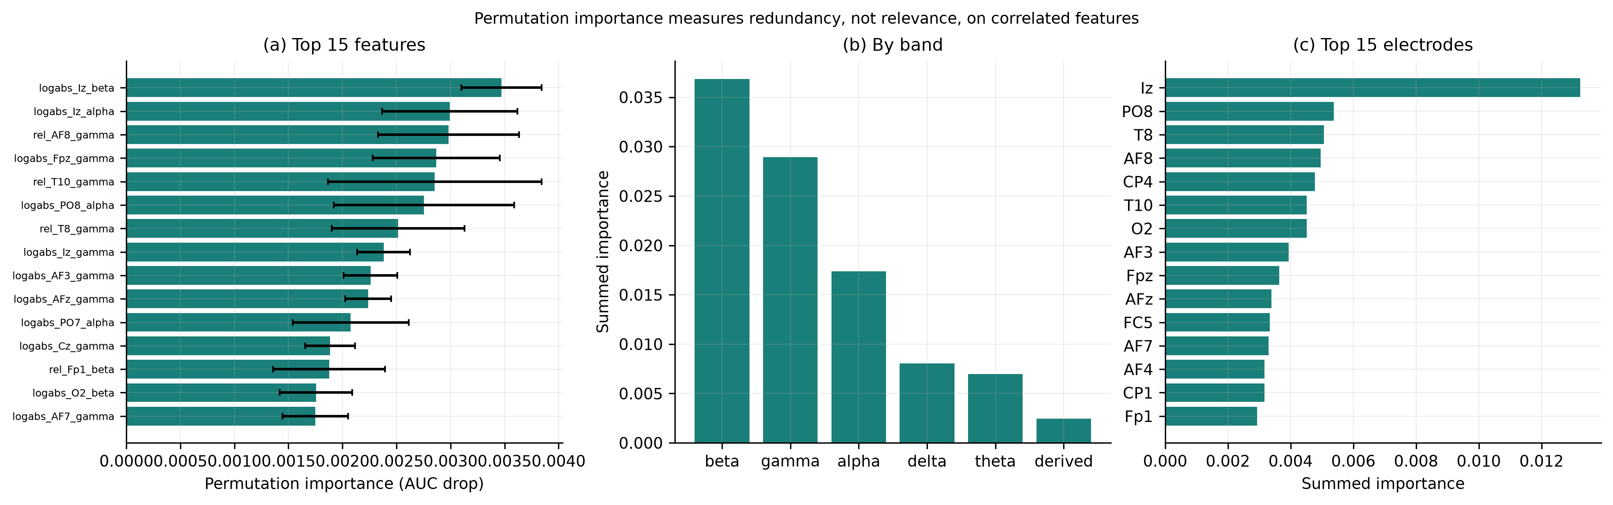
Figure 8. Permutation importance by feature, band, and electrode. On correlated features this measures redundancy, not relevance.
Between-participant variability:
Under leave-one-subject-out validation across all 106 participants, mean accuracy was 0.777 ± 0.160 and pooled AUC 0.877. The median participant reached 0.827 and three were classified perfectly, but 18 of 106 fell below 0.60 and the worst reached 0.240 — substantially worse than chance, meaning the model was confidently wrong about that person. The aggregate figure conceals a long tail. Since occipital alpha increased in all 106 participants, the failures reflect magnitude, not direction: individuals with weak alpha modulation are not well served by a group-trained model. Reporting only mean accuracy would hide this entirely, and a deployment claim resting on the mean would fail for roughly one user in six.
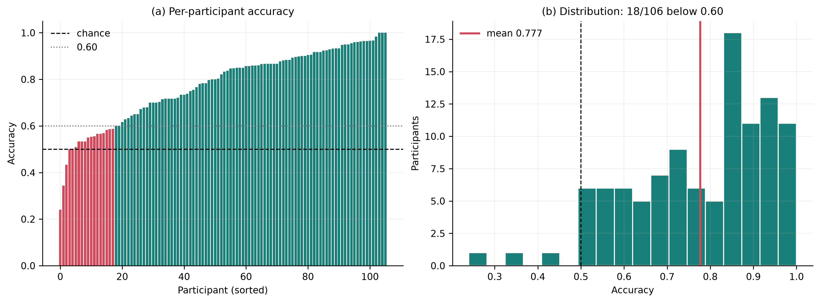
Figure 9. (a) Per-participant accuracy under leave-one-subject-out validation. (b) The distribution; 18 of 106 fall below 0.60.
Discussion
Restatement of key findings:
The physiological effect is enormous and universal in this sample: occipital alpha power rises 5.4-fold on eye closure, in every one of 106 participants. The classification problem it defines is correspondingly easy, and this is exactly why classification accuracy is a poor headline. Performance saturates almost immediately. One electrode and one feature deliver AUC 0.817–0.830; sixty-four electrodes and 674 features deliver 0.894. The marginal return on nearly all of the apparatus is about six points.
The useful levers are elsewhere. Electrode placement is worth +0.054 AUC at a one-electrode budget and nothing at nine. Recording time buys a steady improvement through at least four seconds and, past a short window, outperforms electrode count outright: one occipital electrode at 8 s beats the full 64-channel montage at 0.5 s. Model family buys nothing measurable — four very different learners span 0.021 AUC, which is less than the inflation a single cross-validation error produces.
Neuroscientific interpretation and significance:
What the data demonstrate. Occipital alpha rises 5.4× on eye closure and occipital beta 1.7×, while delta falls to 0.71×; effects are largest at posterior electrodes, and the classification information is heavily redundant across bands and electrodes.
A plausible biological explanation. The posterior topography is consistent with generation in occipital and parieto-occipital cortex under thalamocortical control⁷, where rhythmic bursting in thalamic relay and reticular nuclei entrains cortical populations. On the gating-by-inhibition account^{4,5}, eye closure removes patterned visual input, and high-amplitude alpha reflects active pulsed suppression of visual cortex rather than passive idling. Eye opening restores input, and the resulting desynchronization⁶ both reduces alpha amplitude and broadens the spectrum. That posterior electrodes show the strongest differences follows from proximity to these generators and from the fact that scalp EEG is dominated by the nearest synchronous cortical sources. The beta increase is more ambiguous. It may partly reflect harmonics of a large ~10 Hz oscillation appearing near 20 Hz, and partly genuine beta-band change; these data cannot separate the two, and I make no such claim.
What I explicitly do not claim. Nothing here establishes causation. That a feature is useful to a classifier does not mean it generates the difference, and feature-importance rankings on correlated EEG features can invert the true effect sizes. Nor is the eyes-open/eyes-closed contrast purely visual: the conditions differ in arousal as well as sensory input², and this design cannot disentangle them.
Comparison with previous work:
The direction, topography, and approximate magnitude of the alpha effect match Barry et al². and Barry and De Blasio³, which supports the validity of the pipeline. The observation that a penalized linear model sits within 0.004 AUC of the best nonlinear alternative is consistent with Lotte et al., who report that linear classifiers remain competitive on EEG⁸. The finding that performance saturates at a handful of electrodes is encouraging for the low-channel systems reviewed by Casson²⁷ and benchmarked against research-grade hardware by Ratti et al.²⁸, with the important qualification that placement, not merely channel count, determines whether a low-channel system works — a frontal headband electrode performed no better than a randomly placed one here.
Connection to objectives:
Electrode count, window length, and model complexity can all be reduced very far before eyes-open / eyes-closed classification degrades meaningfully, and the complexity is worth very little. A single occipital electrode with a single alpha feature achieves ROC-AUC 0.817–0.830 on participants never seen in training. Adding 63 electrodes and 673 features raises this to 0.894 — an improvement of about 0.06 AUC for roughly two orders of magnitude more hardware and computation. Model family is worth less still: four learners from penalized linear to gradient boosting span 0.021 AUC. Electrode placement is worth +0.054 AUC at a one-electrode budget and nothing at nine, and beyond a short window recording time outperforms electrode count outright.
Alpha shows by far the largest univariate effect, yet information is so redundant that removing every alpha feature costs only 0.002 AUC: alpha is sufficient but not necessary for classification, because eye closure reshapes the entire spectrum. Posterior sites dominate, and a frontal headband electrode performs slightly worse than a randomly placed one. Generalization to unseen participants is good on average but the mean hides a long tail, with 18 of 106 participants below 0.60 and one at 0.240.
One methodological result is worth as much as the main finding. Splitting epochs at random instead of by participant inflates AUC from 0.893 to 0.940 — an error that yields more apparent improvement than the entire machine-learning apparatus does honestly, and more than twice the spread across every model family tested.
Limitations:
(1) Condition is confounded with run. Eyes-open and eyes-closed were recorded as separate consecutive runs, so any slow drift in impedance, alertness, or electrode contact between runs is perfectly confounded with condition. This is inherent to the paradigm and cannot be resolved within this dataset; an interleaved-block design would be required.
(2) Differential epoch rejection. Eyes-open epochs were rejected roughly twice as often as eyes-closed (13.6% vs 7.8%; paired t p = 0.012, Wilcoxon p = 5.5 × 10⁻⁴), consistent with blinks, and the surviving epoch counts differ accordingly (2,745 vs 2,959). The robustness analysis shows the result is identical with no rejection at all (AUC 0.894 either way), so this does not drive the findings, but it remains an asymmetry in the data.
(3) Short recordings. 61 seconds per condition limits the number of long windows. The 4-second condition lost 7 participants and the 8-second condition lost 22, so the long end of the window-length curve rests on a smaller and possibly non-random subsample — participants who lose long epochs are presumably the noisier ones. The apparent dip at 8 seconds should be read as an artifact of that attrition, not as saturation, and the question of where performance actually plateaus cannot be answered with 61-second recordings.
(4) Homogeneous sample. Participants are healthy volunteers of unreported demographics recorded on one system in one laboratory. Generalization to clinical populations, other hardware, or dry electrodes is untested.
(5) One dataset, one contrast. The cost curves reported here are specific to a large, spatially focal, low-dimensional effect. A subtler or more distributed contrast — mental workload, attention state, early pathology — would very plausibly show a different shape, and complexity might well earn its keep there. This is the single most important caveat: my conclusion is that complexity is unnecessary for this problem, not that it is unnecessary in general.
(6) The bad-channel detector misses clipped electrodes. Injecting known faults into these recordings showed that flat, near-dead, high-amplitude and decorrelated channels are caught reliably, but a railing or clipped electrode was caught only about 60% of the time: clipping lowers variance and preserves correlation with neighbors, so it evades both criteria. The 123 flags should therefore be read as gross faults detected, not as a complete census of imperfect channels.
(7) Simulated rather than measured deployment. Electrode subsets were formed by discarding channels from a 64-channel average-referenced recording. A true one-electrode system would have a different reference, different noise, and no neighbors to interpolate from, and would likely perform somewhat worse than the estimate reported here.
(8) Limited hyperparameter search. The analysis ran on a single CPU core, so tree-model grids were small. Given that the two nonlinear models both underperformed logistic regression, I do not think a larger search would overturn the conclusion, but I cannot exclude it.
Recommendations for future work:
For anyone building a low-cost system for this class of contrast: spend the budget on electrode placement and window length rather than channel count or model sophistication, validate on held-out participants, and report the per-participant distribution rather than the mean. Future work should test whether the saturation shape holds for harder contrasts where the effect is smaller and more distributed; whether personalized calibration rescues the poorly classified tail; whether these curves survive on genuinely low-channel dry-electrode hardware rather than simulated subsets; and whether the beta increase is harmonic or physiologically independent.
Closing thought:
This study confirms a finding from 1929, and the confirmation is not the contribution. The contribution is the measurement of what the modern apparatus adds to Berger's observation, and the answer — about six points of AUC, less than a single cross-validation mistake would fabricate — is one that studies reporting only a final accuracy figure would never surface.
References
1. H. Berger. Über das Elektrenkephalogramm des Menschen. Archiv für Psychiatrie und Nervenkrankheiten. Vol. 87, pg. 527-570, 1929, https://doi.org/10.1007/BF01797193.
2. R. J. Barry, A. R. Clarke, S. J. Johnstone, C. A. Magee, J. A. Rushby. EEG differences between eyes-closed and eyes-open resting conditions. Clinical Neurophysiology. Vol. 118, pg. 2765-2773, 2007, https://doi.org/10.1016/j.clinph.2007.07.028.
3. R. J. Barry, F. M. De Blasio. EEG differences between eyes-closed and eyes-open resting remain in healthy ageing. Biological Psychology. Vol. 129, pg. 293-304, 2017, https://doi.org/10.1016/j.biopsycho.2017.09.010.
4. O. Jensen, A. Mazaheri. Shaping functional architecture by oscillatory alpha activity: gating by inhibition. Frontiers in Human Neuroscience. Vol. 4, pg. 186, 2010, https://doi.org/10.3389/fnhum.2010.00186.
5. W. Klimesch. Alpha-band oscillations, attention, and controlled access to stored information. Trends in Cognitive Sciences. Vol. 16, pg. 606-617, 2012, https://doi.org/10.1016/j.tics.2012.10.007.
6. G. Pfurtscheller, F. H. Lopes da Silva. Event-related EEG/MEG synchronization and desynchronization: basic principles. Clinical Neurophysiology. Vol. 110, pg. 1842-1857, 1999, https://doi.org/10.1016/S1388-2457(99)00141-8.
7. S. W. Hughes, V. Crunelli. Thalamic mechanisms of EEG alpha rhythms and their pathological implications. The Neuroscientist. Vol. 11, pg. 357-372, 2005, https://doi.org/10.1177/1073858405277450.
8. F. Lotte, L. Bougrain, A. Cichocki, M. Clerc, M. Congedo, A. Rakotomamonjy, F. Yger. A review of classification algorithms for EEG-based brain-computer interfaces: a 10 year update. Journal of Neural Engineering. Vol. 15, pg. 031005, 2018, https://doi.org/10.1088/1741-2552/aab2f2.
9. V. Jayaram, A. Barachant. MOABB: trustworthy algorithm benchmarking for BCIs. Journal of Neural Engineering. Vol. 15, pg. 066011, 2018, https://doi.org/10.1088/1741-2552/aadea0.
10. G. Schalk, D. J. McFarland, T. Hinterberger, N. Birbaumer, J. R. Wolpaw. EEG motor movement/imagery database (eegmmidb), version 1.0.0. PhysioNet. 2009, https://doi.org/10.13026/C28G6P.
11. A. L. Goldberger, L. A. N. Amaral, L. Glass, J. M. Hausdorff, P. C. Ivanov, R. G. Mark, J. E. Mietus, G. B. Moody, C.-K. Peng, H. E. Stanley. PhysioBank, PhysioToolkit, and PhysioNet: components of a new research resource for complex physiologic signals. Circulation. Vol. 101, pg. e215-e220, 2000, https://doi.org/10.1161/01.CIR.101.23.e215.
12. G. Schalk, D. J. McFarland, T. Hinterberger, N. Birbaumer, J. R. Wolpaw. BCI2000: a general-purpose brain-computer interface (BCI) system. IEEE Transactions on Biomedical Engineering. Vol. 51, pg. 1034-1043, 2004, https://doi.org/10.1109/TBME.2004.827072.
13. [Self-citation withheld to preserve anonymity during review. The archived analysis code and results will be cited here in the published version.]
14. A. Gramfort, M. Luessi, E. Larson, D. A. Engemann, D. Strohmeier, C. Brodbeck, R. Goj, M. Jas, T. Brooks, L. Parkkonen, M. Hämäläinen. MEG and EEG data analysis with MNE-Python. Frontiers in Neuroscience. Vol. 7, pg. 267, 2013, https://doi.org/10.3389/fnins.2013.00267.
15. A. Delorme, S. Makeig. EEGLAB: an open source toolbox for analysis of single-trial EEG dynamics including independent component analysis. Journal of Neuroscience Methods. Vol. 134, pg. 9-21, 2004, https://doi.org/10.1016/j.jneumeth.2003.10.009.
16. H. H. Jasper. The ten-twenty electrode system of the International Federation. Electroencephalography and Clinical Neurophysiology. Vol. 10, pg. 371-375, 1958.
17. N. Bigdely-Shamlo, T. Mullen, C. Kothe, K.-M. Su, K. A. Robbins. The PREP pipeline: standardized preprocessing for large-scale EEG analysis. Frontiers in Neuroinformatics. Vol. 9, pg. 16, 2015, https://doi.org/10.3389/fninf.2015.00016.
18. M. Chaumon, D. V. M. Bishop, N. A. Busch. A practical guide to the selection of independent components of the electroencephalogram for artifact correction. Journal of Neuroscience Methods. Vol. 250, pg. 47-63, 2015, https://doi.org/10.1016/j.jneumeth.2015.02.025.
19. P. D. Welch. The use of fast Fourier transform for the estimation of power spectra: a method based on time averaging over short, modified periodograms. IEEE Transactions on Audio and Electroacoustics. Vol. 15, pg. 70-73, 1967, https://doi.org/10.1109/TAU.1967.1161901.
20. C. Babiloni, R. J. Barry, E. Başar, K. J. Blinowska, A. Cichocki, W. H. I. M. Drinkenburg, W. Klimesch, R. T. Knight, F. Lopes da Silva, P. Nunez, R. Oostenveld, J. Jeong, R. Pascual-Marqui, P. Valdes-Sosa, M. Hallett. International Federation of Clinical Neurophysiology (IFCN) - EEG research workgroup: recommendations on frequency and topographic analysis of resting state EEG rhythms. Part 1. Clinical Neurophysiology. Vol. 131, pg. 285-307, 2020, https://doi.org/10.1016/j.clinph.2019.06.234.
21. W. Klimesch. EEG alpha and theta oscillations reflect cognitive and memory performance: a review and analysis. Brain Research Reviews. Vol. 29, pg. 169-195, 1999, https://doi.org/10.1016/S0165-0173(98)00056-3.
22. S. Saeb, L. Lonini, A. Jayaraman, D. C. Mohr, K. P. Kording. The need to approximate the use-case in clinical machine learning. GigaScience. Vol. 6, pg. 1-9, 2017, https://doi.org/10.1093/gigascience/gix019.
23. S. Kaufman, S. Rosset, C. Perlich, O. Stitelman. Leakage in data mining: formulation, detection, and avoidance. ACM Transactions on Knowledge Discovery from Data. Vol. 6, pg. 15, 2012, https://doi.org/10.1145/2382577.2382579.
24. F. Pedregosa, G. Varoquaux, A. Gramfort, V. Michel, B. Thirion, O. Grisel, M. Blondel, P. Prettenhofer, R. Weiss, V. Dubourg, J. Vanderplas, A. Passos, D. Cournapeau, M. Brucher, M. Perrot, É. Duchesnay. Scikit-learn: machine learning in Python. Journal of Machine Learning Research. Vol. 12, pg. 2825-2830, 2011.
25. Y. Benjamini, Y. Hochberg. Controlling the false discovery rate: a practical and powerful approach to multiple testing. Journal of the Royal Statistical Society: Series B. Vol. 57, pg. 289-300, 1995, https://doi.org/10.1111/j.2517-6161.1995.tb02031.x.
26. G. Varoquaux. Cross-validation failure: small sample sizes lead to large error bars. NeuroImage. Vol. 180, pg. 68-77, 2018, https://doi.org/10.1016/j.neuroimage.2017.06.061.
27. A. J. Casson. Wearable EEG and beyond. Biomedical Engineering Letters. Vol. 9, pg. 53-71, 2019, https://doi.org/10.1007/s13534-018-00093-6.
28. E. Ratti, S. Waninger, C. Berka, G. Ruffini, A. Verma. Comparison of medical and consumer wireless EEG systems for use in clinical trials. Frontiers in Human Neuroscience. Vol. 11, pg. 398, 2017, https://doi.org/10.3389/fnhum.2017.00398.

